3-4

1. 10 pt

The stem and leaf plots will vary based on the width used for the stem. As long as valid plots are made that is fine with me. I used R to create these (and the students should do them ‘by hand’) so my plots have a lot more than necessary.

Ohm: 20

_____________________________________

1 | 2: represents 1.2, leaf unit: 0.1

Quarter Half

_____________________________________

3 110| 19* |

(8) 33332222| 19 |

4 544| 19 |

1 6| 19 |77 2

| 19 |9 3

| 20 |011 6

| 20 |223 (3)

| 20 |445 6

| 20 |6 3

| 20. |8 2

| 21* |

_____________________________________

HI: 24.4

n: 15 15

_____________________________________

Ohm: 75

_________________________________

1 | 2: represents 1.2, leaf unit: 0.1

Quarter Half

LO: 68.6

_________________________________

| 70* |

1 9| 70. |

| 71* |

2 8| 71. |7 2

7 43310| 72* |1 3

(6) 997655| 72. |8 4

2 42| 73* |2 5

| 73. |89 7

| 74* |02 (2)

| 74. |68 6

| 75* |0 4

| 75. |

| 76* |2 3

| 76. |57 2

| 77* |

_________________________________

n: 15 15

_________________________________

Ohm: 100

_______________________________

1 | 2: represents 1.2, leaf unit: 0.1

Quarter Half

_______________________________

5 98861| 94 |

(3) 841| 95 |5 1

7 00| 96 |68 3

5 743| 97 |229 6

2 53| 98 |57 (2)

| 99 |2 7

| 100 |00 6

| 101 |

| 102 |000 4

| 103 |0 1

_______________________________

n: 15 15

_______________________________

Ohm: 150

____________________________________________

1 | 2: represents 1.2, leaf unit: 0.1

Quarter Half

LO: 145 146

____________________________________________

3 000| 147* |0 3

| 147. |

(11) 00000000000| 148* |0 4

| 148. |

1 0| 149* |0000 8

| 149. |

| 150* |00 7

____________________________________________

HI: 151 152 153

154 155

n: 15 15

____________________________________________

Ohm: 200_________________________________

1 | 2: represents 12, leaf unit: 1

Quarter Half

_________________________________

| 19 |

1 3| 19 |2 1

5 5554| 19 |5 2

(6) 666666| 19 |677 5

4 9998| 19 |9 6

| 20 |1 7

| 20 |2 (1)

| 20 |5 7

| 20 |77 6

| 20 |

| 21 |01 4

| 21 |

| 21 |4 2

| 21 |

| 21 |

| 22 |

_________________________________

HI: 257

n: 15 15

_________________________________

These plots show us that the quarter Watt resistors have a distribution that seems to have a lower average than the ½ Watt resistors. The ¼ watt resistors also seem to have less spread than the ½ watt resistors.

1. 10 pt

Following are the numeric summaries necessary to build the boxplots

1/2.20 1/4.20 1/2.75 1/4.75 1/2.100 1/4.100 1/2.150 1/4.150 1/2.200 1/4.200

lower.whisker 19.7 19 71.7 71.8 95.5 94.1 145 148 192 193

q1 20.025 19.2 72.9 72.15 97.2 94.825 148.25 148 197 195

median 20.2 19.3 74 72.5 98.7 95.8 149 148 202 196

q3 20.475 19.375 74.95 72.85 101.5 97.375 151.75 148 209.25 197.5

upper.whisker 20.8 19.6 76.7 73.4 103 98.5 155 148 214 199

outliers 24.4 Numeric,0 68.6 70.9 Numeric,0 Numeric,0 Numeric,0 147x3,149 257 Numeric,0

“Numeric,0” in the outliers row just means there aren’t any outliers

Ohms: 20

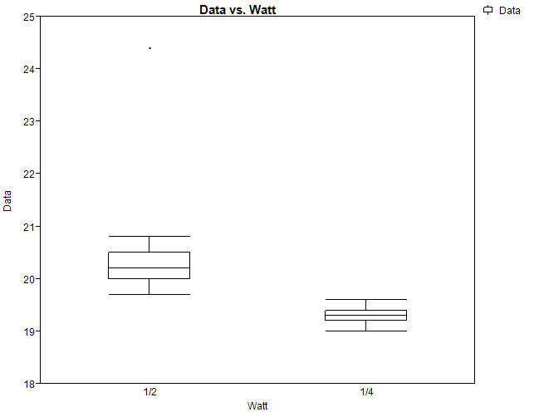

Ohms: 75

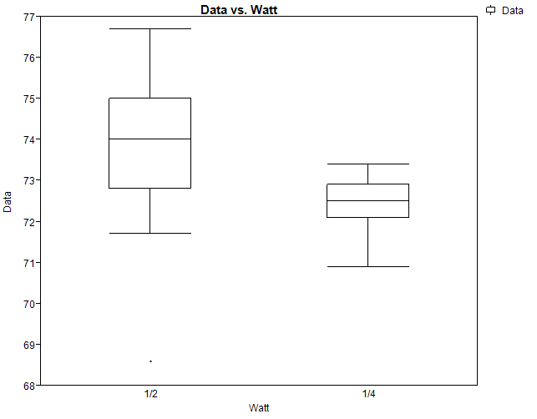

Ohms: 100

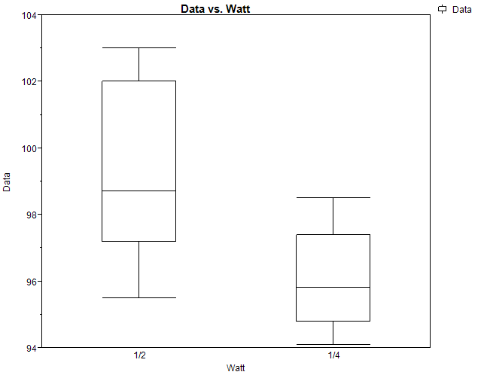

Ohms: 150

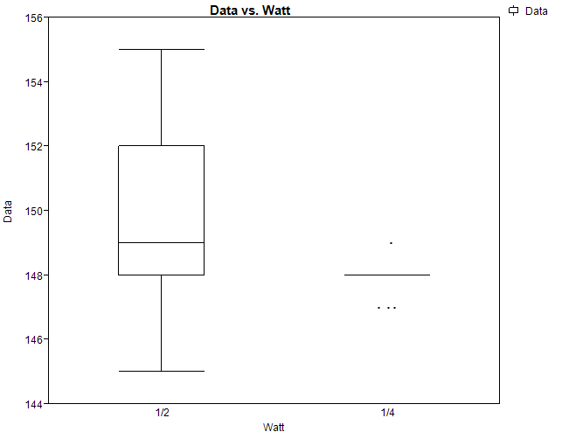

Ohms: 200

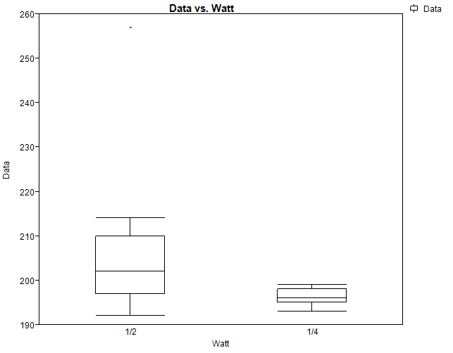

1. 10 pts

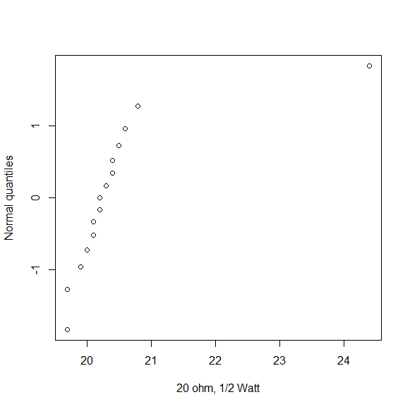

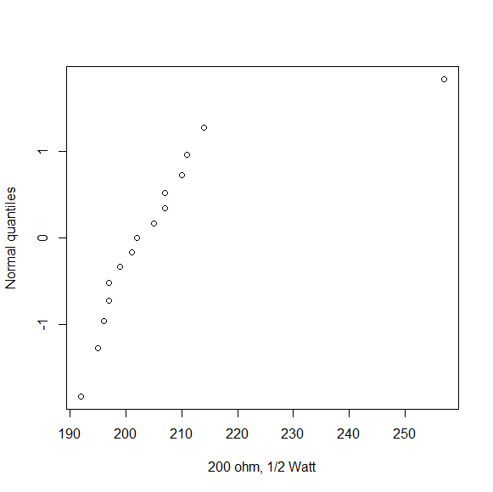

For the most part the plots look like a straight line could go through them fairly well except for the upper ‘outlier’ point. So it appears like we would underestimate the number of ‘Large’ values we would see in the data.

1. 10 pts

Label mean StdDev

1 1/2W100 99.10667 2.3260840

2 1/2W150 149.80000 2.8334734

3 1/2W20 20.48667 1.1262242

4 1/2W200 206.00000 15.5333742

5 1/2W75 73.87333 2.0765585

6 1/4W100 96.04667 1.4371930

7 1/4W150 147.86667 0.5163978

8 1/4W20 19.27333 0.1579632

9 1/4W200 196.20000 1.8205180

10 1/4W75 72.43333 0.6067085

These do appear to agree with the statement that the 1/4Watt resistors tend to have smaller averages and small spreads

1. 5 pts

It doesn’t specify whether to break make 5 lines (one for each ohm) or 2 lines (one for each Watt) so I’ll present both…

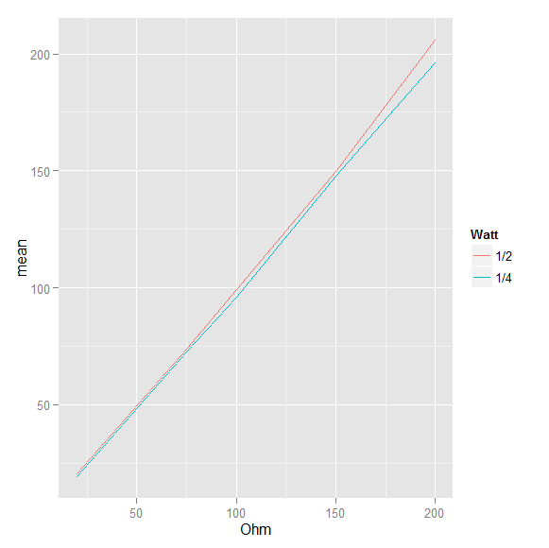

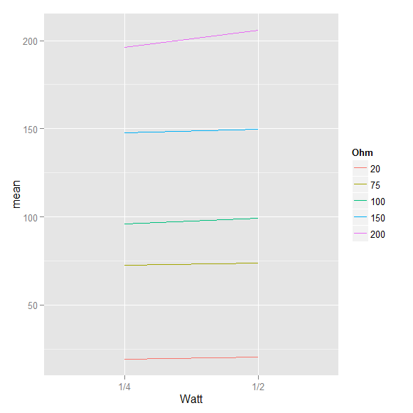

Both plots show the ¼ Watt resistors having a lower mean than the ½ plot resistors but we also see that the difference between the means gets larger as Ohms increases.

3-11)

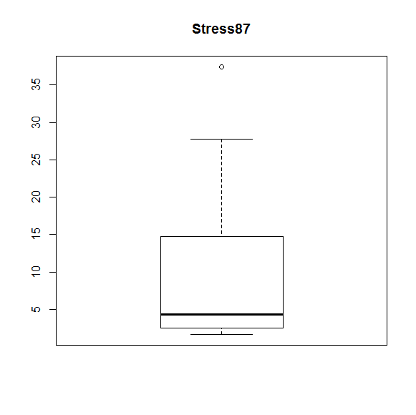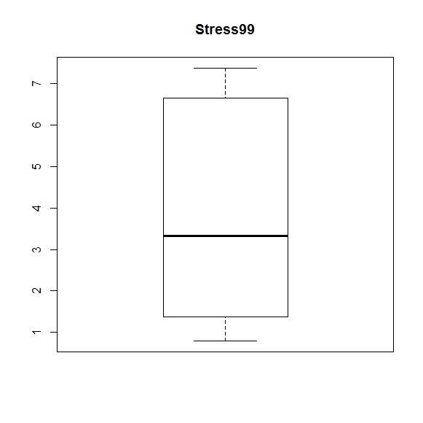

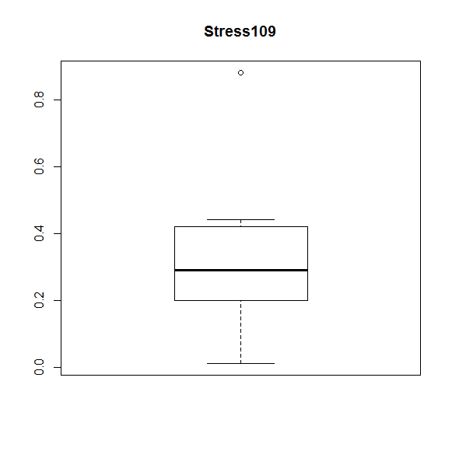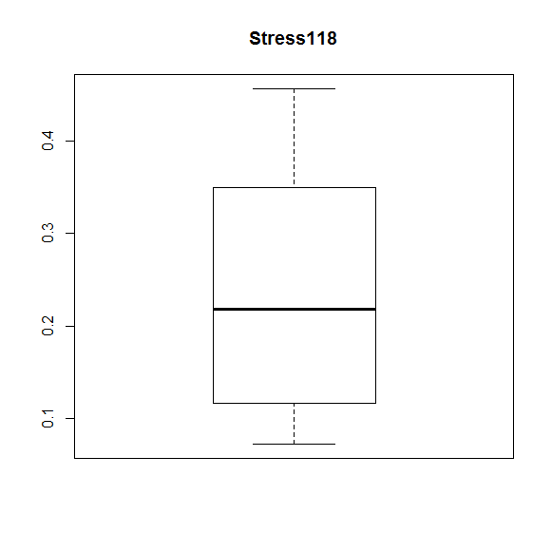

1. 10 pts

The problem said “side-by-side boxplots” which typically means we put them all on the same scale. But since we want to analyze shape it makes more sense to give them each their own axis to compare the actual shape of the boxplots. We only have 10 data values for each plot so we would need to see major differences to try to claim there are big differences. The .87x10^6psi distribution looks more skewed than the others.

1. 10 pts

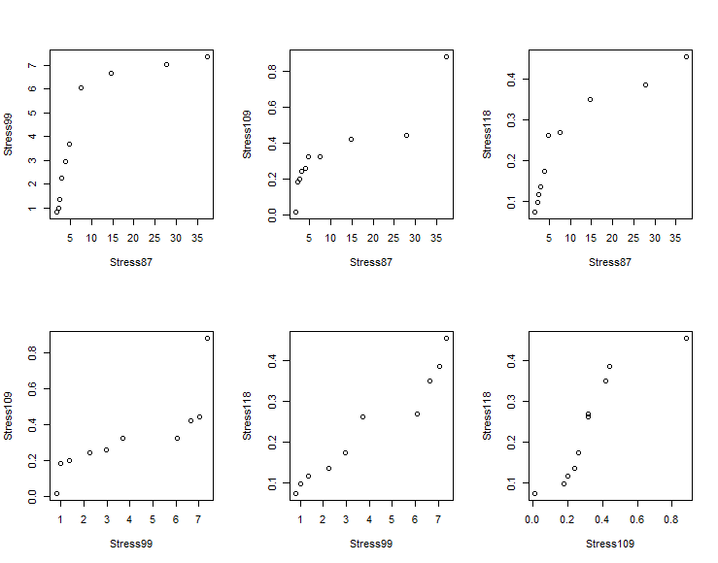

From the plots on the top row we can see that stress87 seems to be more right skewed than stress99 and stress118. There does appear to be a little variation in the shape of the distributions but with so few data points its hard to put too much faith into an assessment like that. Although it wouldn’t be perfect there probably wouldn’t be too much of an issue assuming that these had similar shapes (but larger difference centers and scales). Answers will vary – as long as there is an honest attempt to analyze the shapes that should suffice.

3-21

1. 5 pts

The median will be the mean of the 5th and 6th smallest sorted values in this case:

Median = 532.8

The first and third quartiles are actually just the 3rd and 8th observations:

Q1 = 526.8

Q3 = 536.6

For Q(.27) we have I’ = 10*.27 + .5 = 3.2 so Q(.27) = .8*x[3] + .2*x[4] where x[3] is the 3rd smallest observation:

Q(.27) = .8*526.8 + .2*531.6 = 527.76

1. 5 pts

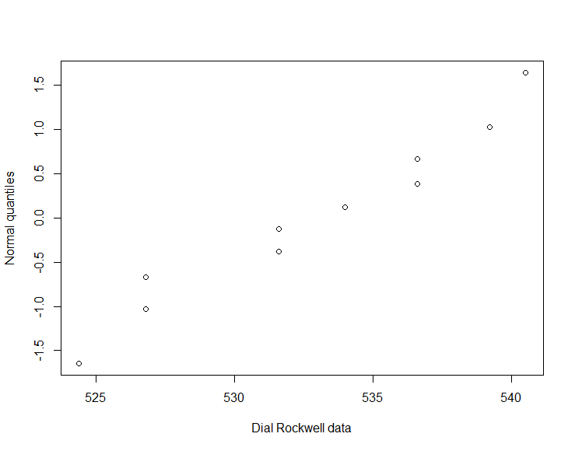

This looks like the data does fall pretty much on a straight line so there I wouldn’t have an issue with somebody describing it as bell-shaped.

1. 10 pts

|  |  |  |  |  |
| --- | --- | --- | --- | --- |
| Label | N Rows | Mean(Data) | Std Dev(Data) | Range(Data) |
| Brinell | 10 | 545.97 | 35.31773 | 88.4 |
| Dial | 10 | 532.81 | 5.53784 | 16.1 |
| Digital | 10 | 518.01 | 8.776287 | 30.4 |

1. 5 pts
2. 5 pts

Using JMP

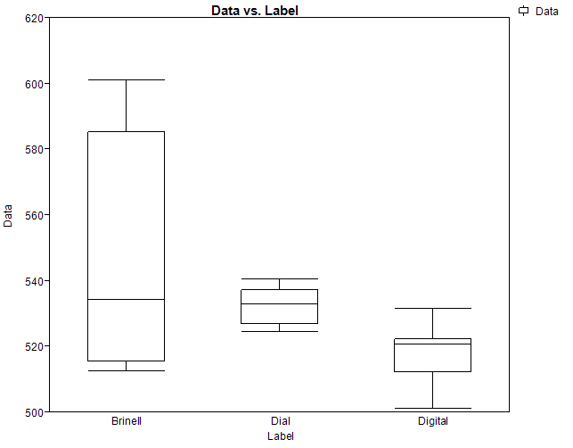

1. 5 pts

The dial Rockwell produced the most precise results. It has the most compact boxplot. Looking at the summaries from part c suggest that it has the least amount of variation as well.

1. 5 pts

It is not possible to tell which machine produced the most accurate results. To know if the machines are accurate we would need to know what the “true” value was for each measurement. Since we don’t have that information we can’t assess accuracy.

4-1)

|  |  |  |  |  |  |  |  |
| --- | --- | --- | --- | --- | --- | --- | --- |
|  | x | Y | x - xbar | y - ybar | (x-xbar)*(y-ybar) | (x-xbar)^2 | (y - ybar)^2 |
|  | 0.45 | 2954 | -0.05 | 188.1111 | -9.405555556 | 0.0025 | 35385.79012 |
|  | 0.45 | 2913 | -0.05 | 147.1111 | -7.355555556 | 0.0025 | 21641.67901 |
|  | 0.45 | 2923 | -0.05 | 157.1111 | -7.855555556 | 0.0025 | 24683.90123 |
|  | 0.5 | 2743 | 0 | -22.8889 | 0 | 0 | 523.9012346 |
|  | 0.5 | 2779 | 0 | 13.11111 | 0 | 0 | 171.9012346 |
|  | 0.5 | 2739 | 0 | -26.8889 | 0 | 0 | 723.0123457 |
|  | 0.55 | 2652 | 0.05 | -113.889 | -5.694444444 | 0.0025 | 12970.67901 |
|  | 0.55 | 2607 | 0.05 | -158.889 | -7.944444444 | 0.0025 | 25245.67901 |
|  | 0.55 | 2583 | 0.05 | -182.889 | -9.144444444 | 0.0025 | 33448.34568 |
| sum | 4.5 | 24893 | 1.67E-16 | 1.82E-12 | -47.4 | 0.015 | 154794.8889 |

1. 12 pts

xbar = 4.5/9 = 0.5

ybar = 24893/9 = 2765.89

b1 = -47.4/.015 = -3160

b0 = ybar – xbar*b1 = 4345.89

Our fitted regression line is then:

y-hat = 4345.89 – 3160*x

1. 3 pts

r = -47.4/sqrt(.015 * 154794.8889) = -.9837

The correlation of -.98 tells us that we have a strong negative linear relationship between Water/Cement Ratio and 14-Day Compressive Strength.

1. 3 pts

R^2 = r^2 = (-.9837)^2 = 0.967628848

The fitted line accounts for 96.7% of the raw variability in 14-Day Compressive Strength

1. 5 pts

|  |  |  |  |
| --- | --- | --- | --- |
| i | p | Residuals | Normal Q |
| 1 | 0.055555556 | -26.8889 | -1.59162 |
| 2 | 0.166666667 | -24.8889 | -0.96361 |
| 3 | 0.277777778 | -22.8889 | -0.58621 |
| 4 | 0.388888889 | -10.8889 | -0.28044 |
| 5 | 0.5 | -0.88889 | 0 |
| 6 | 0.611111111 | -0.88889 | 0.280438 |
| 7 | 0.722222222 | 13.11111 | 0.586205 |
| 8 | 0.833333333 | 30.11111 | 0.963615 |
| 9 | 0.944444444 | 44.11111 | 1.591622 |

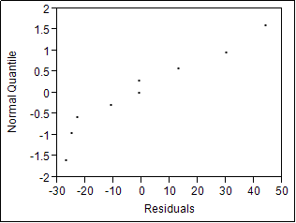

The points don’t fall perfectly on a straight line but the deviation isn’t too bad. It would be reasonable to use a normal distribution to model the residuals.

1. 3 pts

We would just plug in .48 in for x in our regression equation

Predicted value = 4345.89 – 3160*0.48 = 2829.088889

So for a Water/Cement Ratio of .48 we would predict a 14-Day Compressive Strength of 2829.1 psi.

1. 8 pts

Using JMP

y = 4345.8889 - 3160*x

r = -0.9837 (obtained from Multivariate Correlations)

R^2 = .9676

Residual plots can be seen below

**Bivariate Fit of y By x**





**Linear Fit**

y = 4345.8889 - 3160*x

**Summary of Fit**

|  |  |
| --- | --- |
| RSquare | 0.967629 |
| RSquare Adj | 0.963004 |
| Root Mean Square Error | 26.75521 |
| Mean of Response | 2765.889 |
| Observations (or Sum Wgts) | 9 |

**Parameter Estimates**

| **Term** |  | **Estimate** | **Std Error** | **t Ratio** | **Prob>|t|** |
| --- | --- | --- | --- | --- | --- |
| Intercept |  | 4345.8889 | 109.5912 | 39.66 | <.0001* |
| x |  | -3160 | 218.4554 | -14.47 | <.0001* |

**Diagnostics Plots**

**Residual by Predicted Plot**



**Residual Normal Quantile Plot**



**Multivariate**

**Correlations**

|  | **x** | **y** |
| --- | --- | --- |
| x | 1.0000 | -0.9837 |
| y | -0.9837 | 1.0000 |

4-3)

1. 3 pts

They used a complete factorial design. An obvious weakness is that they only have a single replicate for each temperature*time combination.

1. 10 pts

|  |  |
| --- | --- |
| Equation | R^2 |
| Y = -515.15 + .356*x1 + .0107*x2 | .886 |
| Y = -528.46 + .356*x1 + 3.71*ln(x2) | .888 |
| Y = -42.35 + .031*x1 -93.71*ln(x2) + .065*x1*ln(x2) | .962 |

|  |
| --- |
|  |
|  |
|  |
|  |
|  | |
|  | |
|  | |

**Response y**

**Whole Model**

**Summary of Fit**

|  |  |
| --- | --- |
| RSquare | 0.88616 |
| RSquare Adj | 0.848214 |
| Root Mean Square Error | 6.966912 |
| Mean of Response | 22.55556 |
| Observations (or Sum Wgts) | 9 |

**Parameter Estimates**

| **Term** |  | **Estimate** | **Std Error** | **t Ratio** | **Prob>|t|** |
| --- | --- | --- | --- | --- | --- |
| Intercept |  | -515.1503 | 84.98199 | -6.06 | 0.0009* |
| x1 |  | 0.3566667 | 0.056885 | 6.27 | 0.0008* |
| x2 |  | 0.01069 | 0.003932 | 2.72 | 0.0347* |

**Response y**

**Whole Model**

**Summary of Fit**

|  |  |
| --- | --- |
| RSquare | 0.888598 |
| RSquare Adj | 0.851464 |
| Root Mean Square Error | 6.891927 |
| Mean of Response | 22.55556 |
| Observations (or Sum Wgts) | 9 |

**Parameter Estimates**

| **Term** |  | **Estimate** | **Std Error** | **t Ratio** | **Prob>|t|** |
| --- | --- | --- | --- | --- | --- |
| Intercept |  | -528.4622 | 84.31093 | -6.27 | 0.0008* |
| x1 |  | 0.3566667 | 0.056272 | 6.34 | 0.0007* |
| ln(x2) |  | 3.7106558 | 1.338465 | 2.77 | 0.0323* |

**Response y**

**Whole Model**

**Summary of Fit**

|  |  |
| --- | --- |
| RSquare | 0.962152 |
| RSquare Adj | 0.939444 |
| Root Mean Square Error | 4.400523 |
| Mean of Response | 22.55556 |
| Observations (or Sum Wgts) | 9 |

**Parameter Estimates**

| **Term** |  | **Estimate** | **Std Error** | **t Ratio** | **Prob>|t|** |
| --- | --- | --- | --- | --- | --- |
| Intercept |  | -42.35063 | 164.9735 | -0.26 | 0.8076 |
| x1 |  | 0.0310728 | 0.110457 | 0.28 | 0.7897 |
| ln(x2) |  | -93.71554 | 31.26572 | -3.00 | 0.0302* |
| x1*ln(x2) |  | 0.0652553 | 0.020934 | 3.12 | 0.0263* |

1. 10 pts

Residuals plots

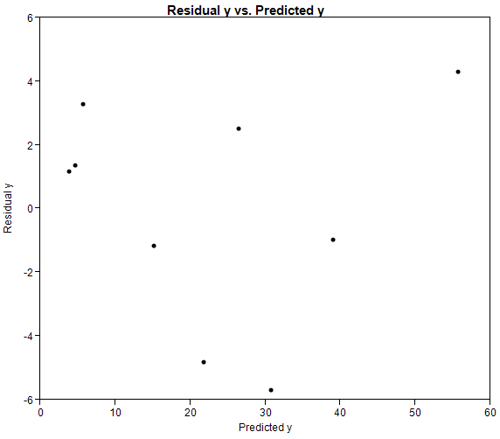

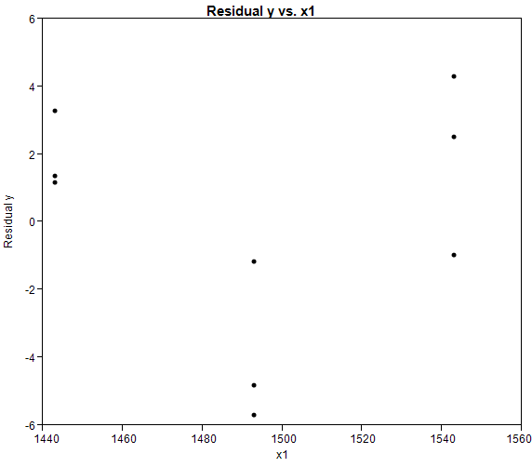

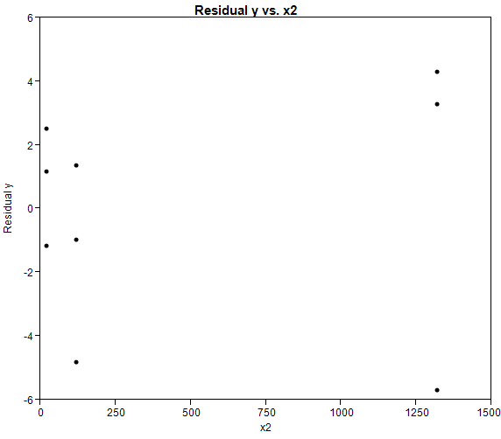

Looking at the residuals by predicted plots it looks like there is still some trend left that could be modeled. The plot of residual by x1 makes it appear like we could probably do a better job of modeling if we used a transformation of x1 instead of just using x1 linearly.

1. Extra credit: + 10 pts if they did a decent job
2. 5 pts

Y = -42.35 + .031*x1 -93.71*ln(x2) + .065*x1*ln(x2) which gives…

Y-hat = -42.35063 + .0310728*1500 -93.71554*log(500) + .0652553*1500*log(500)

= 30.15739